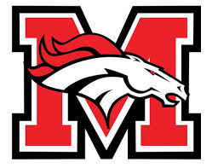
Tech teams
6th Hour

Team One: Nicholas, Colby, Shayna

Team Two: Kayla, Colton, Caleb

Team Three: Donaven, Morgaine, Andrew

Team Four: Tristan, Clayton, Amir

Team Five: Joshua, Kathryn, Andrew

Team Six: Travis, Ian, Madison

Team Seven: Emily, Luke, Tiffany

Team Eight: Zulema, Daytona, Kari,

Team Nine: Alisha, Austin

